POWER BI ASSIGNMENT 1
E-COMMERCE SALES ANALYSIS

Import Data:
● Import “List of Orders.csv” into Power BI.
● Open “List of Orders” in Power Query Editor by clicking on ‘Transform’.
● Import “Order Details.csv” and “Sales target.csv” into Power Query Editor.

Data Transformation:
● Restrict the "List of Orders" table to only the first 500 rows.
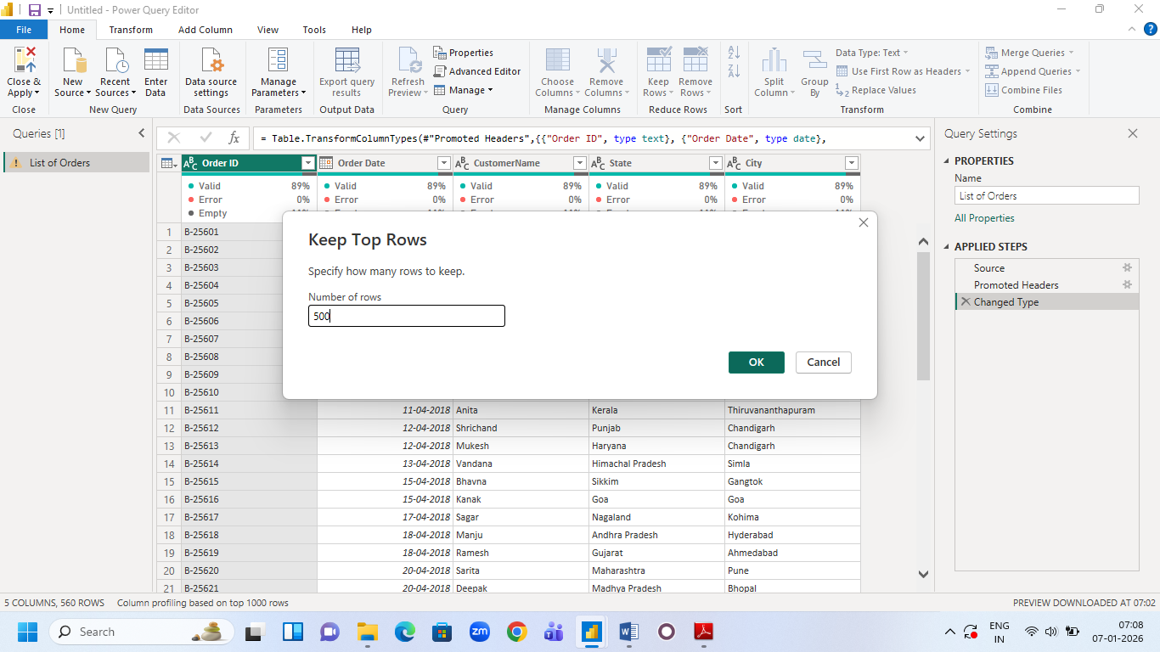

● Ensure the “Order Date” column in the “List of Orders” table is set to data type 'Date'.
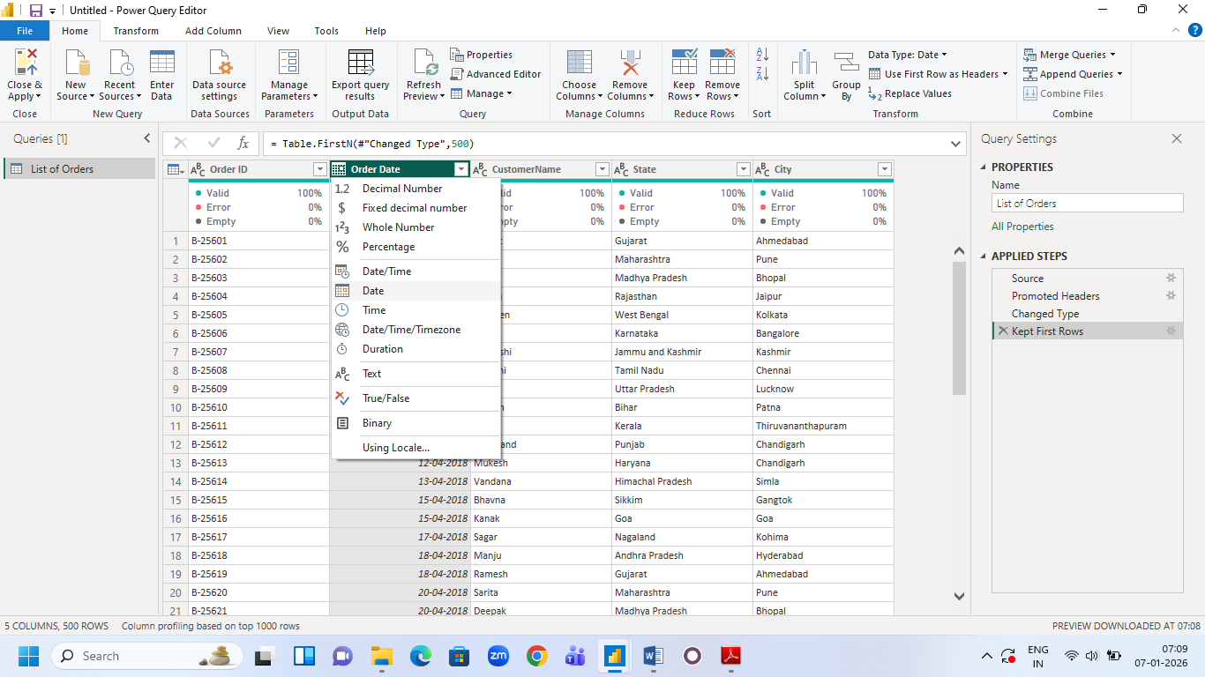

● Format the "CustomerName" column into proper case, ensuring consistent capitalization for each word.
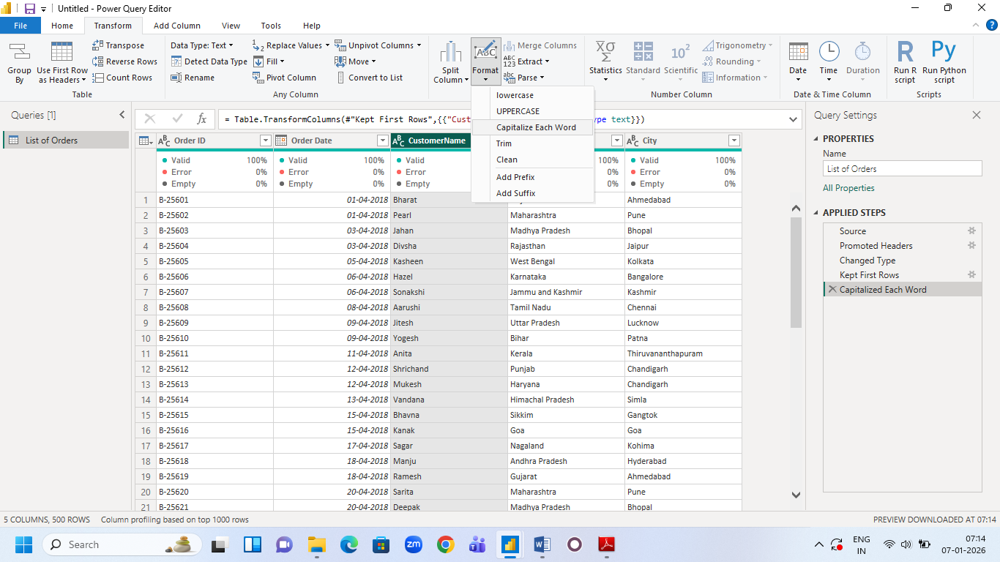

● Import “Order Details.csv” and “Sales target.csv” into Power Query Editor.
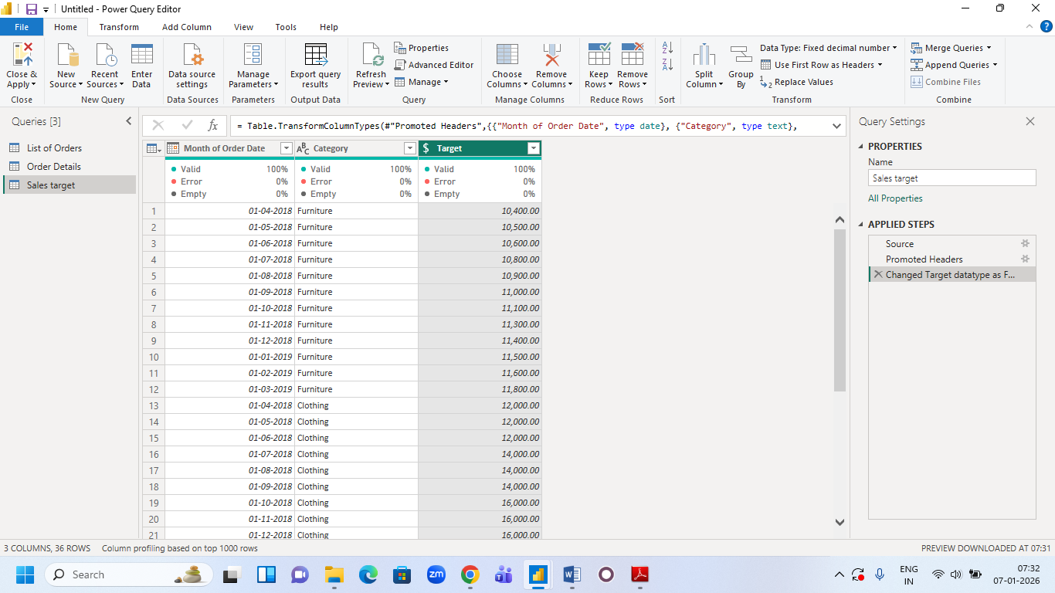

● Change the data type of “Amount” and “Target” columns to ‘Fixed Decimal Number’.
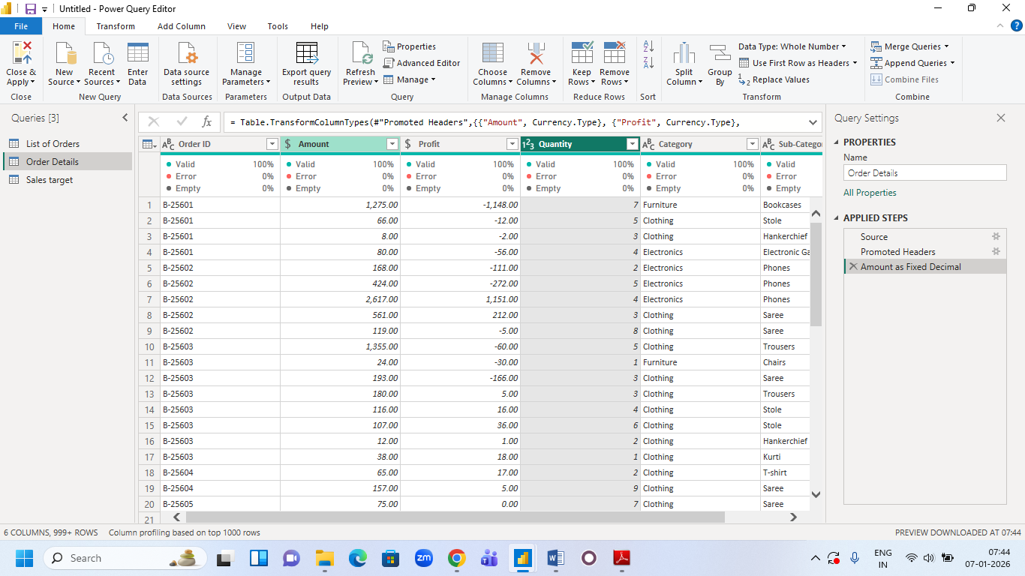
● Merge the "State" and "City" columns to create a new column named "Location" in the format ‘City, State’.
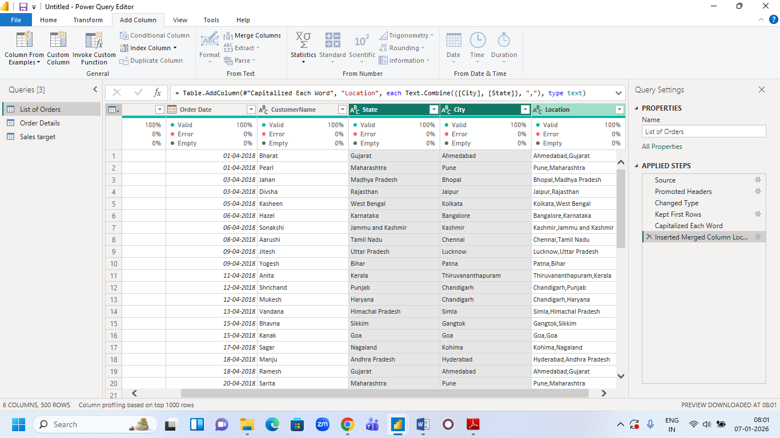

● Create a new custom column named "Profit Margin" as the percentage of "Profit" divided by "Amount". 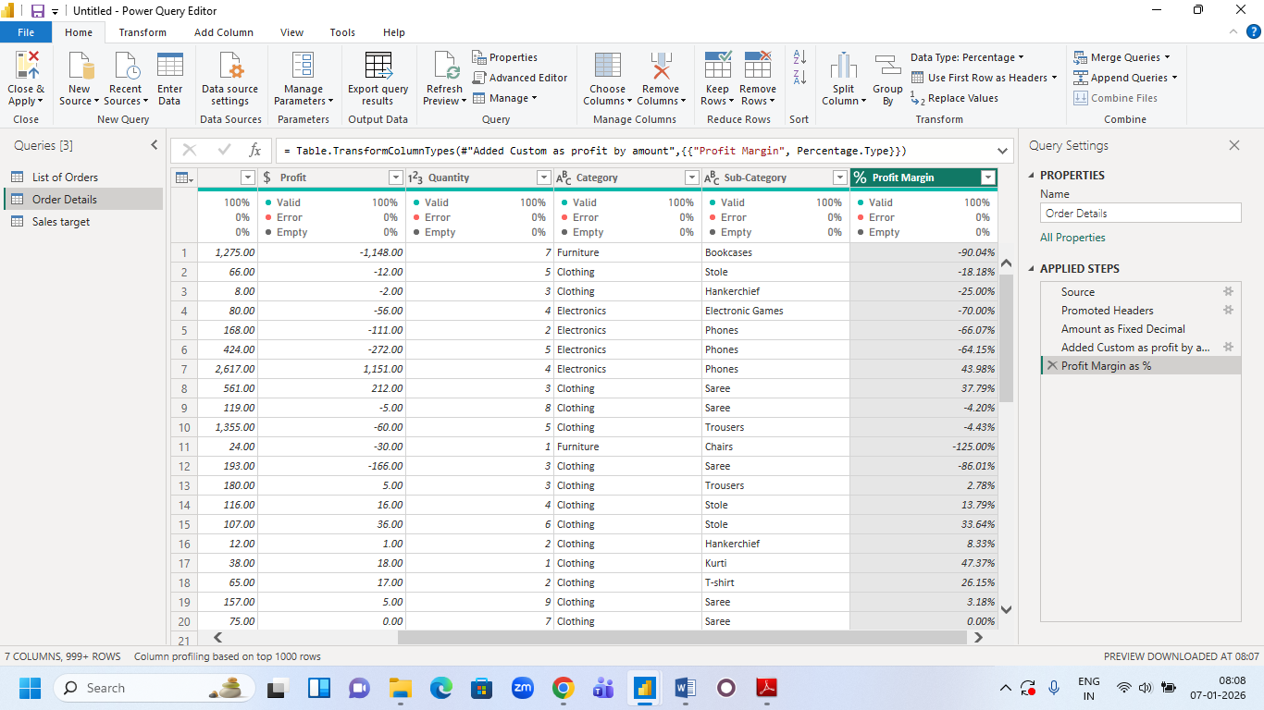

● Add a new conditional column named "Profit Status" based on the values in the "Profit" column. The conditions are as follows: if the profit is less than 0, the label should be "Loss"; if the profit equals 0, the label should be "Break-Even"; and if the profit is greater than 0, the label should be "Profit".

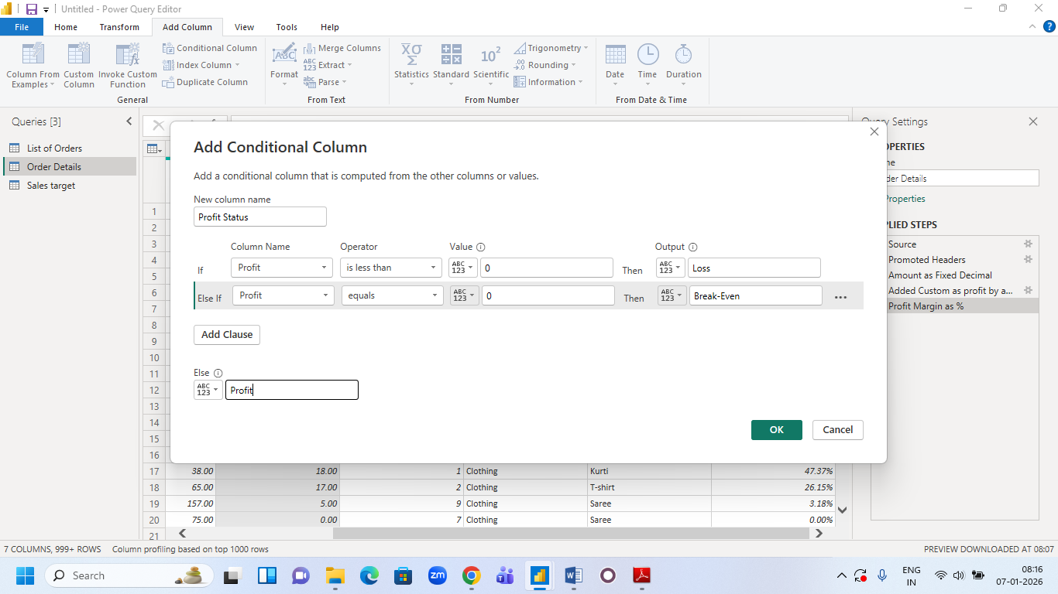

● Merge the "List of Orders" and "Order Details" tables into a new single table named "Orders Data" based on the "Order ID" relationship. 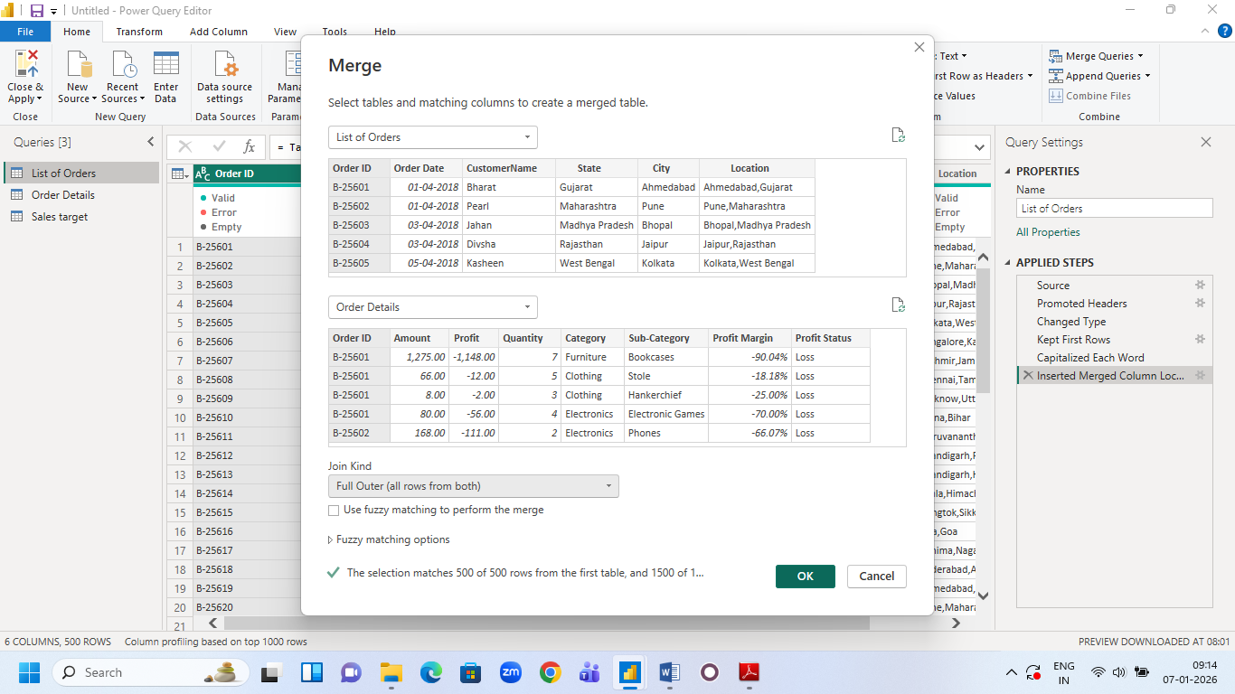

● Identify missing values in the data and determine a strategy to address them.
No missing values, no null values
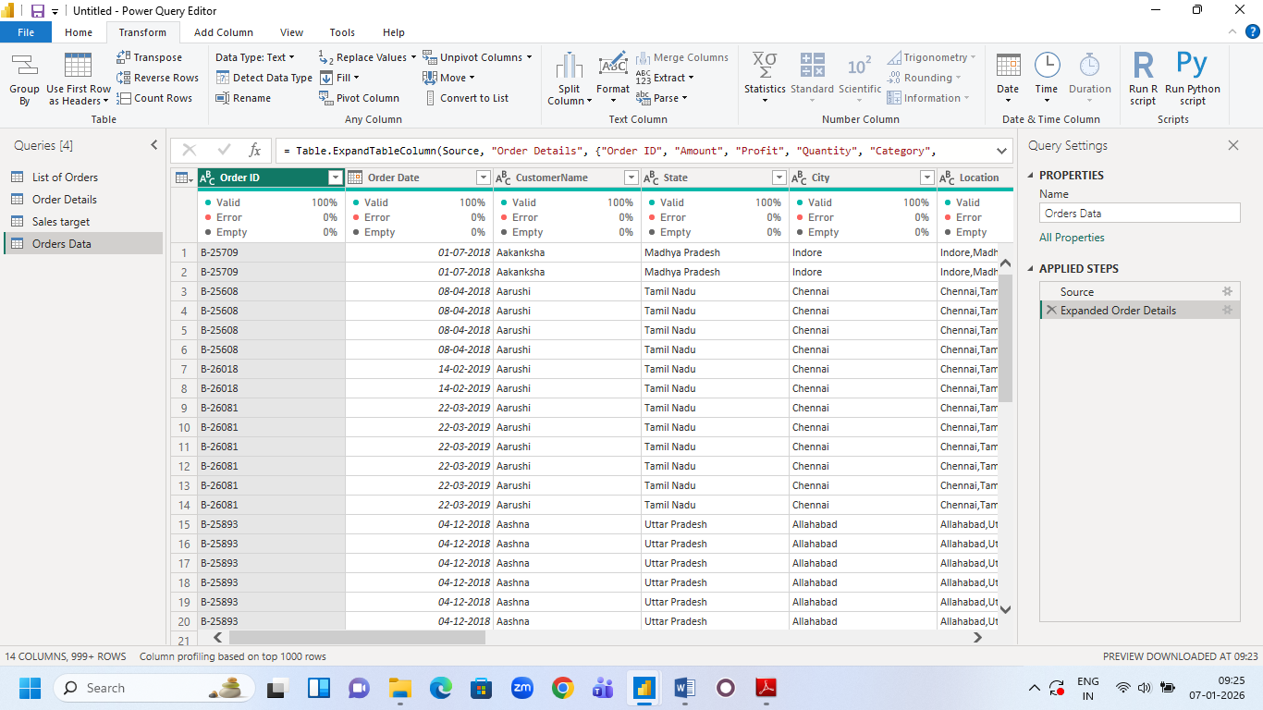
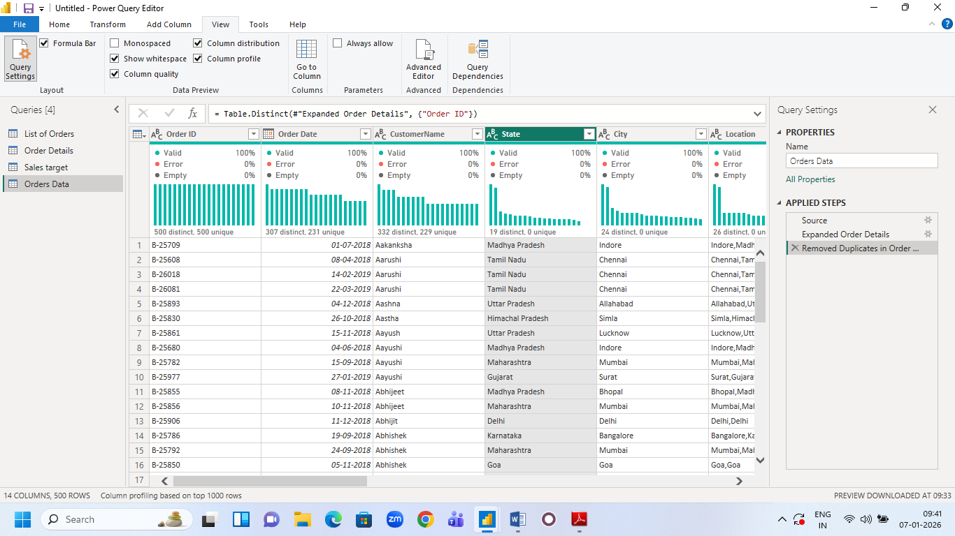

● Check for duplicate rows and define a strategy to handle duplicates.
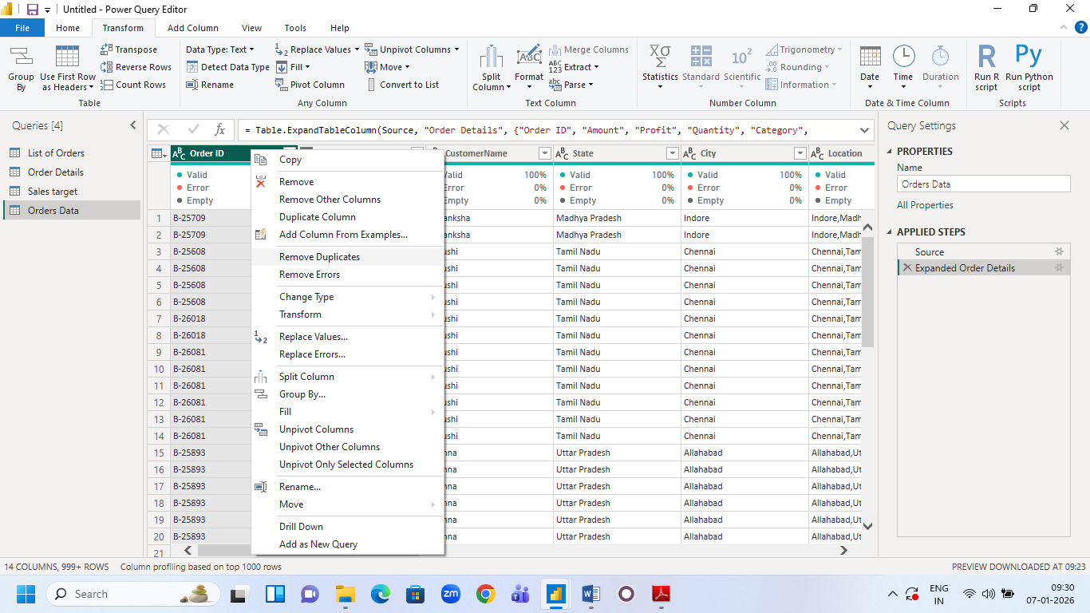
After remove duplicates number of rows decreased
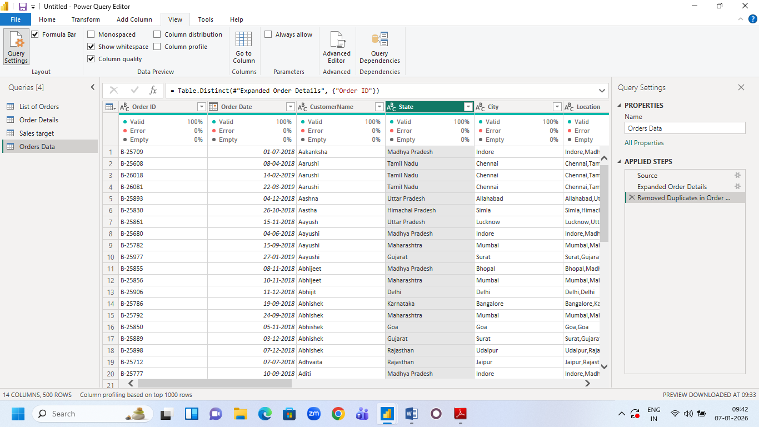

● In the ‘Orders Data’ table, utilize sorting and filtering techniques on columns like Order Date, State or Category to analyze data based on specific criteria:

◆ Sort the orders by Order Date in descending order to analyze recent trends.

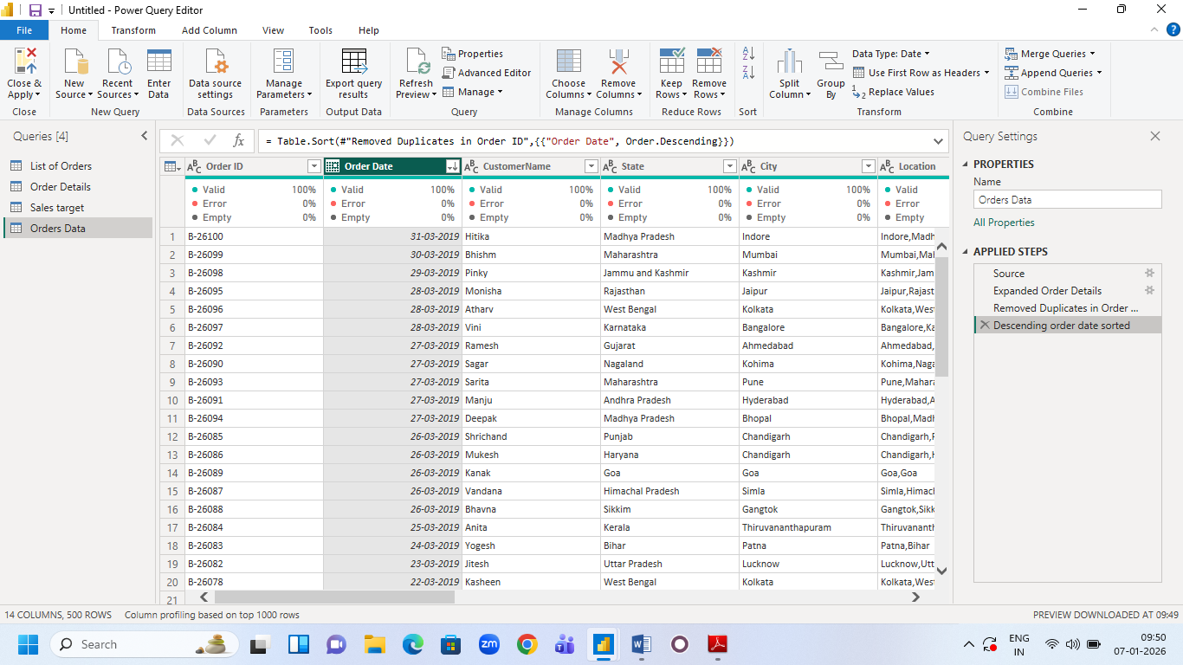

◆ Filter the orders to focus only on a specific state (e.g., Tamil Nadu) for regional analysis.
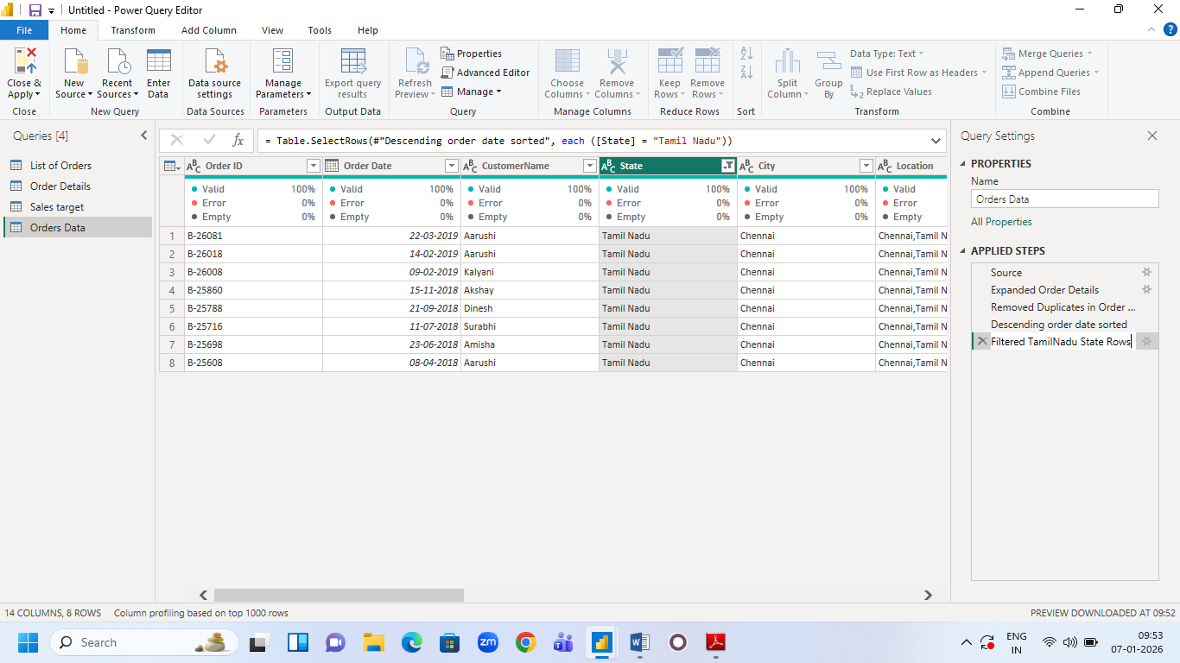

● Duplicate the “Order Details” table and calculate the count of each Order ID, average profit by Category or total amount by Sub-Category.
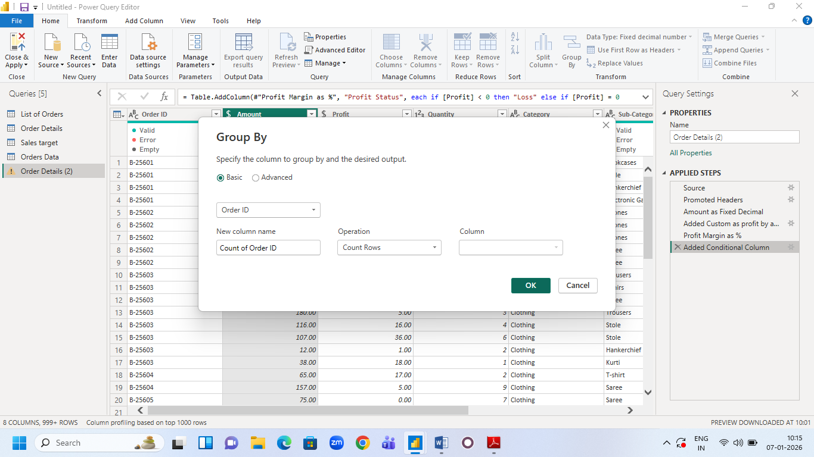

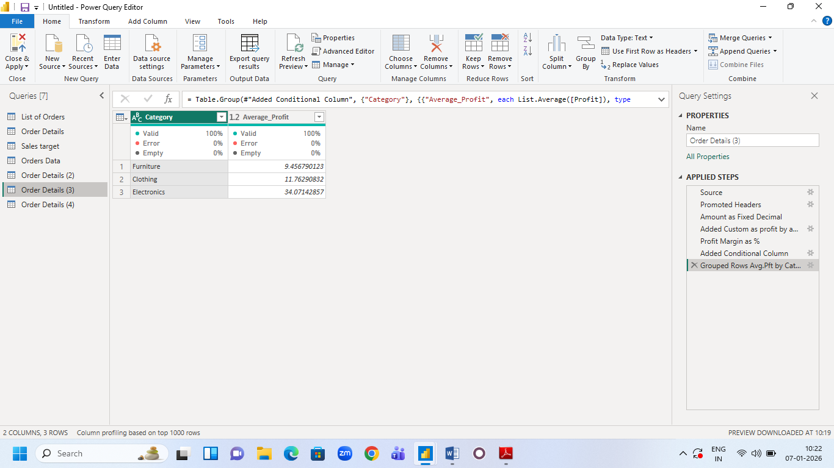
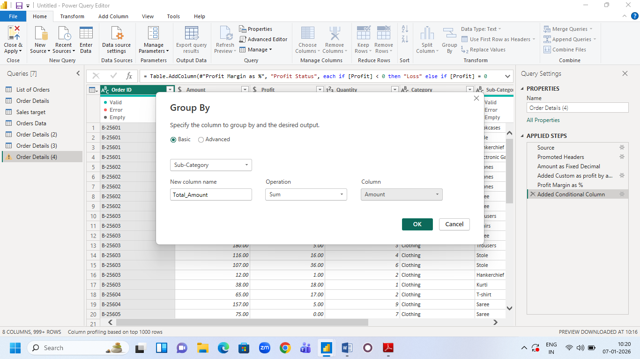

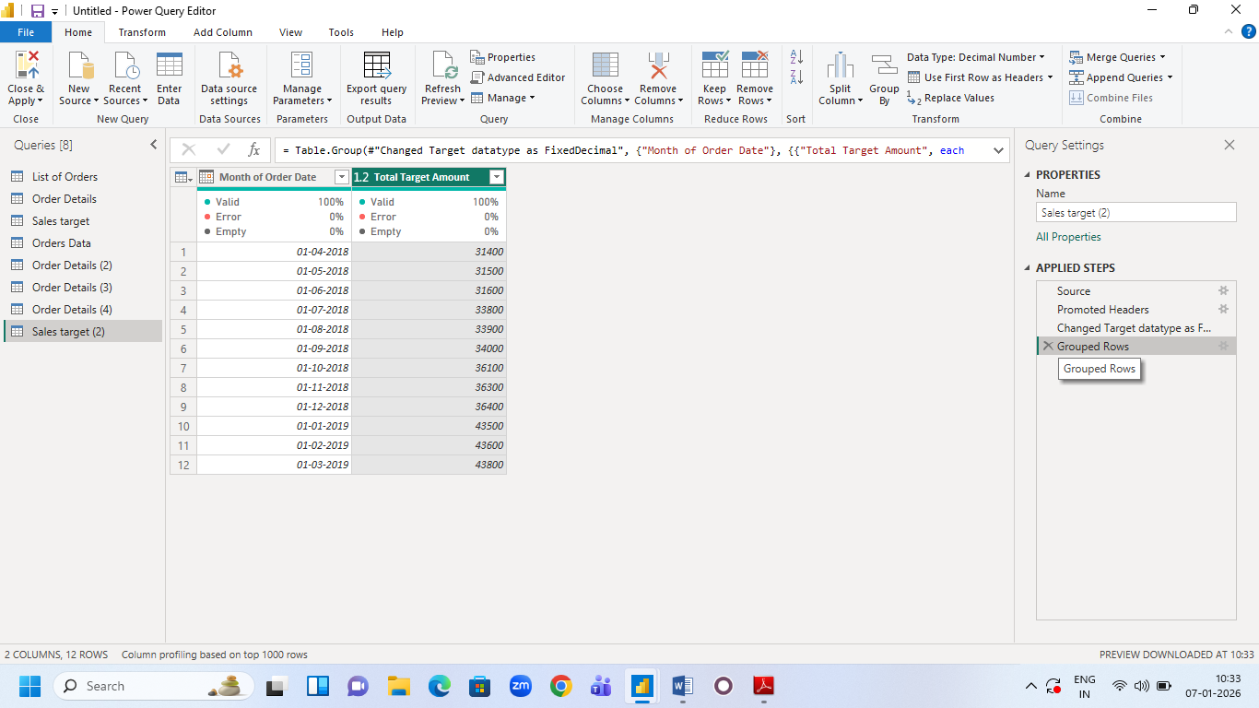

● Establish a relationship between the “List of Orders” and “Order Details” tables using the ‘Order ID’ column.

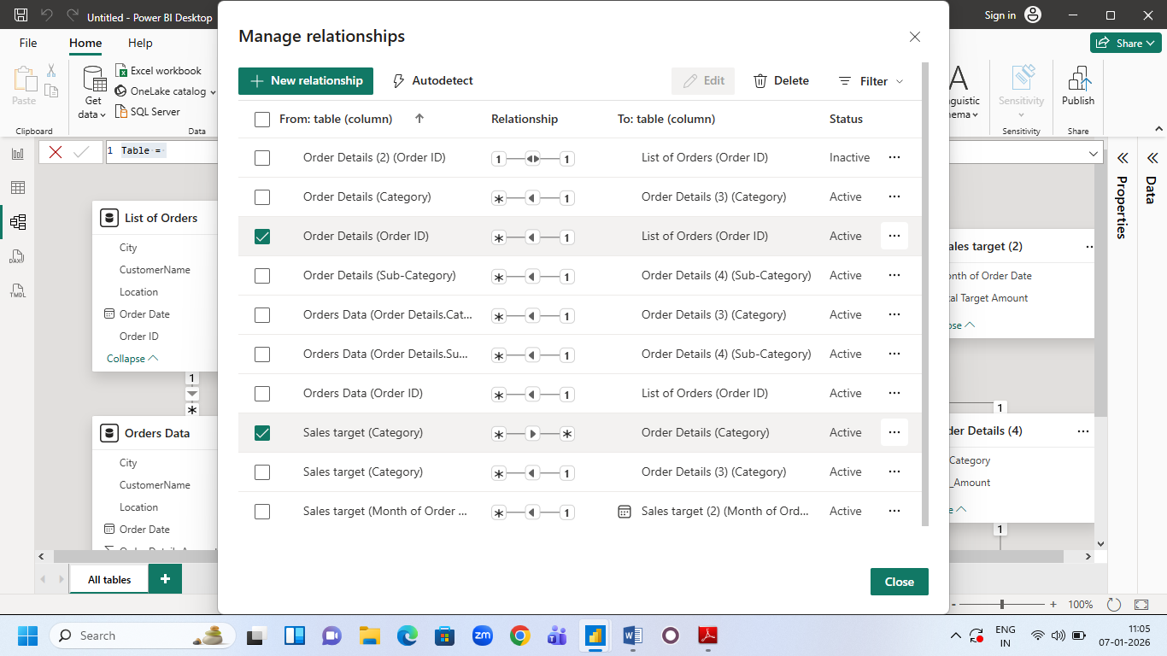

● Build a relationship between the “Order Details” and “Sales Target” tables based on the ‘Category’ column. Click "Manage relationships" and ensure this relationship is active. 